**MS SQL:**

A join statement is used to display results of 2 different tables.

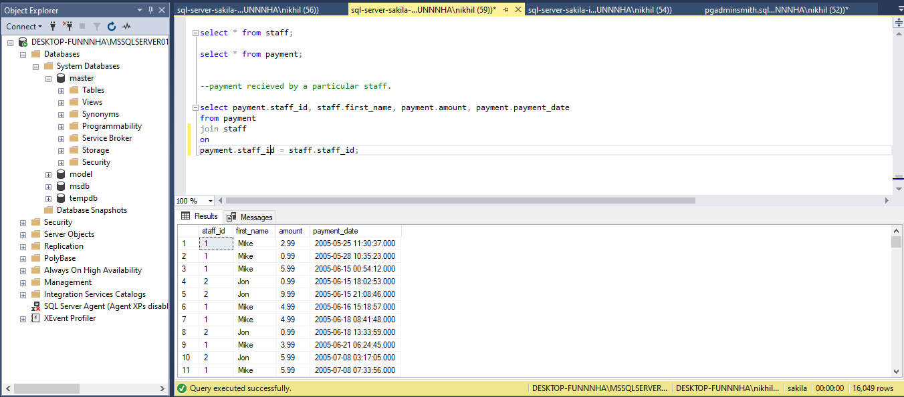

**PostgreSql:**

Displaying actors.

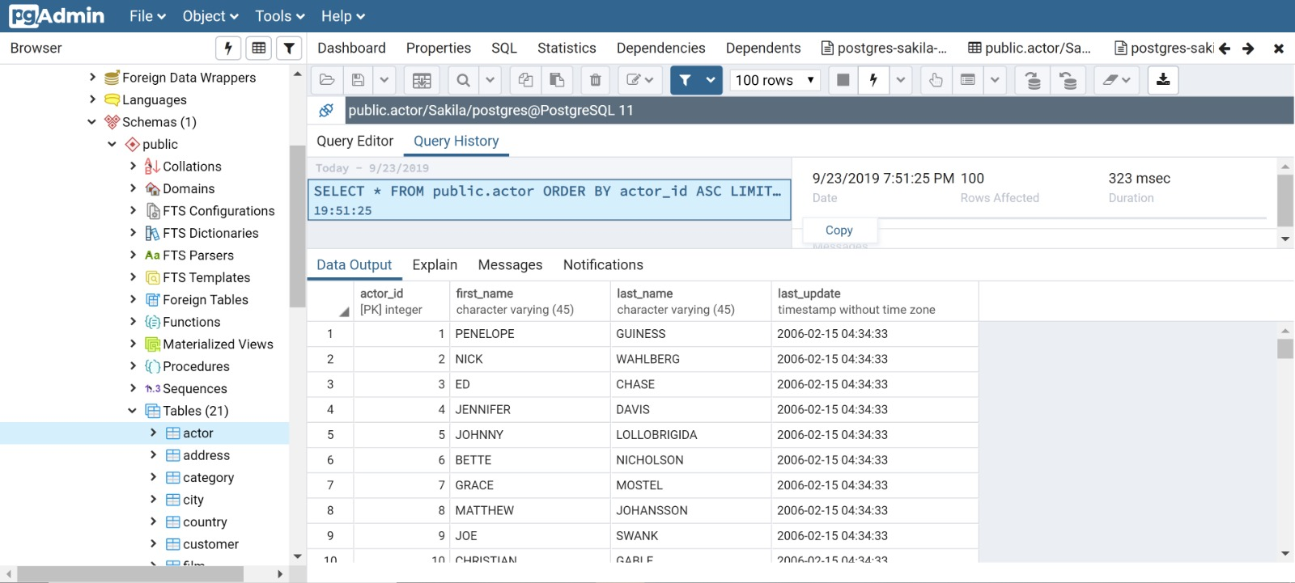

**Oracle:**

Displaying all actors.

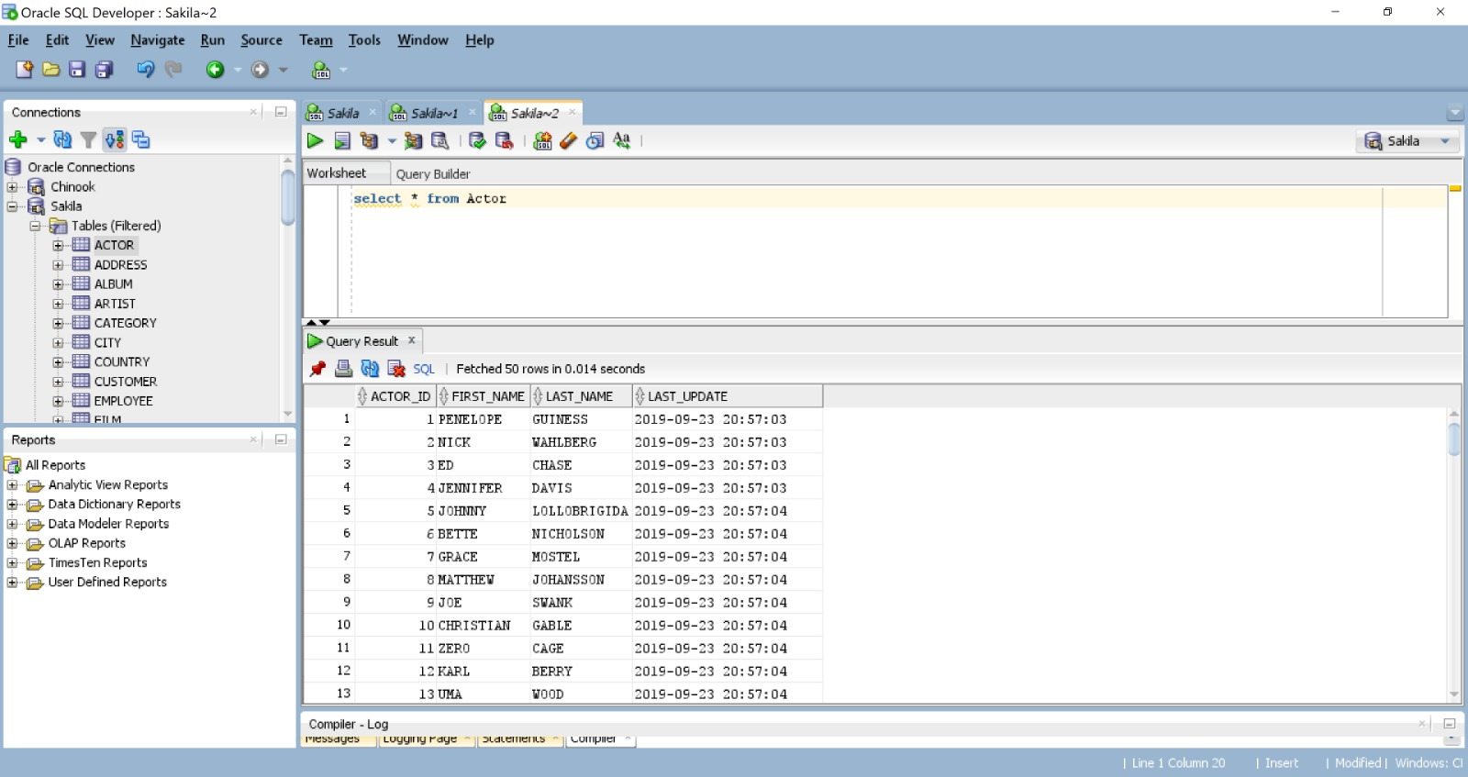

**My SQL:**

Displaying all actors.

